**One-to-one biases in a non-linguistic and non-communicative domain: young children map novel animal vocalizations to unfamiliar animals**

Ricardo Bion, Kyle MacDonald, and Anne Fernald

The disambiguation effect has been documented in dozens of studies on early word learning. This bias in referent selection has been characterized in several ways - as motivated by lexical-specific constraints or principles (Markman, 1991; Mervis & Bertrand, 1994), by pragmatic inferences about speakers’ communicative intentions (Clark, 1990; Diesendruk & Markson, 2001), or by domain-general learning mechanisms that favor simpler hypotheses in complex learning tasks (McMurray et al., in press). Lexical-specific accounts predict that one-to-one biases are unique to word learning, pragmatic accounts predict that they generalize to communicative acts more broadly, and domain-general accounts predict that they apply to any domain in which consistent one-to-one mappings are observed. To explore the domain-general account, this study investigated whether children show one-to-one biases in a domain that is non-linguistic and non-communicative for them, but in which strong regularities can be found: the vocalizations that animals produce.

The first question was whether children could appreciate the associations between familiar animals and their characteristic vocalizations. Specifically, we focused on children’s efficiency in recognizing links between animals and three types of auditory stimuli: the natural animal vocalization (e.g., dog barking), the lexicalized animal sound (e.g. *bow-wow*), and the animal name (e.g., *dog*). Across 20 trials, 30-month-olds (n=19) saw pictures of two familiar animals on a screen (e.g., a dog and a cat) and heard one of the three sounds associated with one of the two animals. As seen in Figure 2.a., children’s mean proportion of looking to the correct animal was computed. The three types of auditory cue were equally efficient in guiding children’s attention to familiar animals. Children reliably looked to the target animal after hearing the animal vocalization, the lexicalized sound, and the animal name (*p* < 0.05), and performance was indistinguishable across the three conditions.

The second question was whether children showed one-to-one biases for the types of vocalizations that animals produce, similar to their biases in word learning. Children saw the picture of a familiar (e.g., dog) and a novel animal (e.g., aardvark). In one condition, children heard either a familiar animal name (e.g., *dog*) or a familiar animal vocalization (e.g. dog barking). In the critical condition, children heard either a novel animal name (e.g., *nadu*) or a novel animal vocalization (e.g., gorilla vocalization). As seen in Figure 2.b., children reliably looked to the familiar animal when hearing the familiar animal name or vocalization. Crucially, they also reliably looked to the novel animal when hearing the novel animal name or vocalization. The proportion of looks to the novel animal was equally high when children heard a novel animal name and an unfamiliar animal vocalization. This is the earliest age at which one-to-one biases have been observed in a domain other than word learning. Crucially, our results cannot be easily explained by pragmatic or lexical-constraints accounts, and seem to favor a domain-general learning mechanism that seeks simple regularities in complex learning tasks.

(1.a)

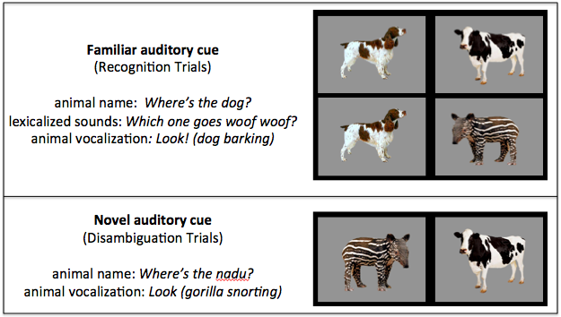

(1.b)

**Figure 1.** Trials organized by type of auditory cue. The target animal for each trial type is on the left and the distractor is on the right. In Recognition trials (1.a.), children heard a familiar auditory cue in the presence of either two familiar or a familiar and a novel animal. In Disambiguation trials (1.b.), children heard a novel auditory cue in the presence of a familiar and novel object.

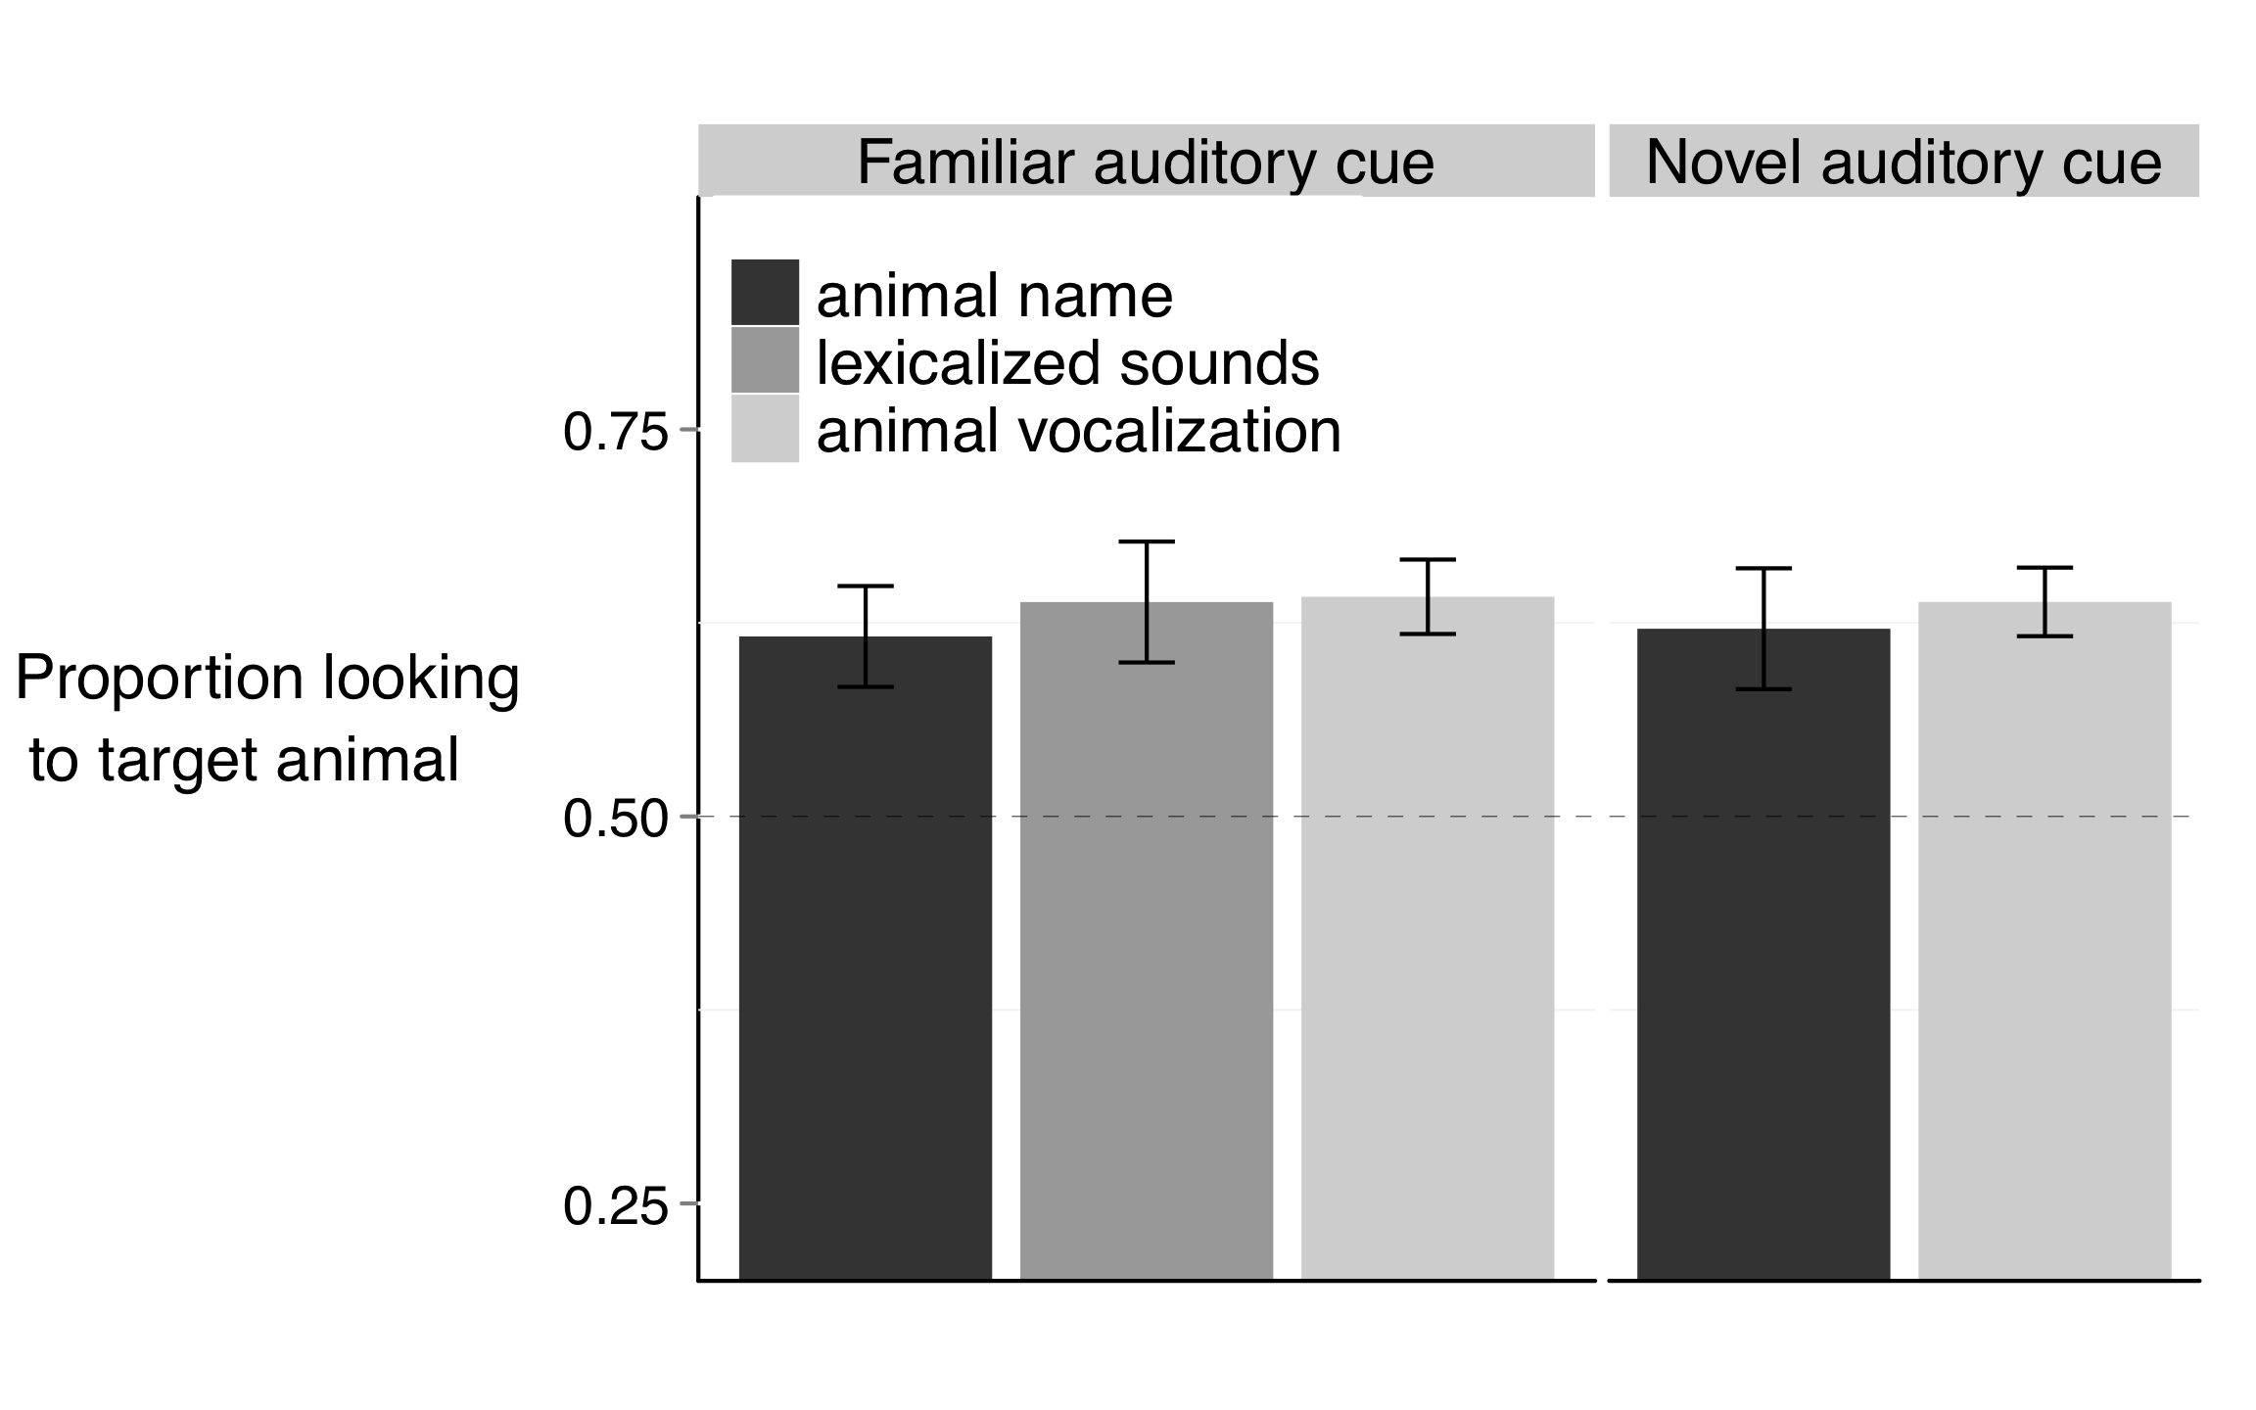

(2.a)

(2.b)

**Figure 2.** Accuracy of responses to familiar (2.a., Recognition trials) and novel auditory cues (2.b., Disambiguation trials). When hearing familiar animal names, lexicalized sounds, or animal vocalizations, children reliably looked to the target familiar animal. When hearing novel animal names or animal vocalizations, children reliably looked at the novel animal instead. The different auditory cues were equally effective in guiding children’s attention to the target.